In Class Normalization Exercise 1
For each:
1) Identify the keys (primary, candidate, foreign)
2) Draw the functional dependency diagram
3) Identify functional dependencies that violate 2NF
4) Identify the functional dependencies that violate 3NF
5) Decompose into a set of relations that satisfies 3NF

- For this first one you will also need to find the functional dependencies.
Invoice (InvNo, InvDate, CustNo, CustName, ItemNo, ItemName, ItemPrice, Qty)

The functional dependencies are:
- InvNo -> InvDate, CustNo
- CustNo -> CustName
- ItemNo -> ItemName, ItemPrice
- InvNo, ItemNo -> Qty

Identify the primary key:
- InvNo, ItemNo

Functional Dependency Diagram

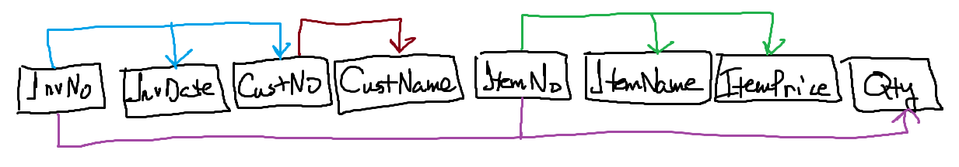
How did we do this? 1) Write down all your attributes, preferably in the order they were given. 2) For each FD, draw the respective dependency line between the attributes. For example, the first FD is InvNo -> InvDate,CustNo. I’ve drawn this line in blue.

The functional dependencies that violate 2NF and 3NF are:
- InvNo -> InvDate, CustNo – Violates 2NF (only defined by partial key)
- CustNo -> CustName – Violates 3NF (defined by a non-key, and CustNo is transitive)
- ItemNo -> ItemName, ItemPrice – Violates 2NF (only defined by partial key)
- InvNo, ItemNo -> Qty - OK

Decompose into a set of Relations that satisfy 3NF
We can create an relation for the FD that violates 3NF:
CustNo -> CustName
Customer(CustNo, CustName)

InvNo -> InvDate, CustNo
Invoice(InvNo, InvDate, CustNo(FK))

ItemNo -> ItemName, ItemPrice
Item(ItemNo, ItemName, ItemPrice)

InvNo, ItemNo -> Qty
InvoiceItem(InvNo(FK), ItemNo(FK), Qty)

Final Result:
Customer(CustNo, CustName)
Invoice(InvNo, InvDate, CustNo(FK))
Item(ItemNo, ItemName, ItemPrice)
InvoiceItem(InvNo(FK), ItemNo(FK), Qty)

- Consider a system that tracks projects and the employees assigned to them, and the charges to have these employees on the job:
Project (ProjNum, ProjName, EmpNum, EmpName, JobClass, ChgHour, Hours)
The functional dependencies:
    - ProjNum → ProjName
    - EmpNum → EmpName, JobClass
    - JobClass → ChgHour
    - ProjNum, EmpNum → Hours

Keys: ProjNum, EmpNum
The functional dependencies that violate 2NF and 3NF are:
- ProjNum -> ProjName – Violates 2NF (only defined by partial key)
- EmpNum -> EmpName, JobClass – Violates 2NF (only defined by partial key)
- JobClass -> ChgHours – Violates 3NF (defined by a non-key, JobClass is transitive)
- ProjNum, EmpNum -> Hours – OK

Functional Dependency Diagram:
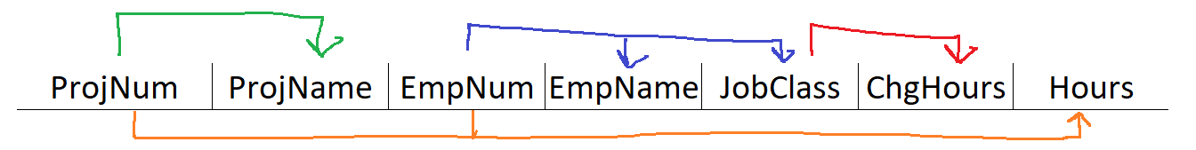
Decomposition of our FDs that violate 2NF/3NF into separate relations:
- Project(ProjNum,ProjName)
- Employee(EmpNum, EmpName, JobClass(FK))
- Cost(JobClass, ChgHour)
- EmployeeTime(ProjNum(FK), EmpNum(FK), Hours)

- A relation that tracks people who are signed up for a course.

CourseRegistration( personId, surname, givenName, address, countryCode, countryName, localCurrency, courseSession, courseDate, courseLocation, registrationDate )
The functional dependencies (figure these out based on their names):
- personID -> surname, givenName, address, countryCode
- countryCode -> countryName, localCurrency
- courseSession -> courseDate, courseLocation
- personId, courseSession -> registrationDate

Keys: personId, courseSession
NOTE: Take a look at the LHS. Gather a list of all attributes on the LHS. Do any of those appear on the RHS (Transitive?). Remove the ones that do. You remaining set of attributes can be used for keys.
The functional dependencies that violate 2NF and 3NF are:
- personID -> surname, givenName, address, countryCode – Violates 2NF (defined by a partial key)
- countryCode -> countryName, localCurrency – Violates 3NF (defined by a non-key)
- courseSession -> courseDate, courseLocation – Violates 2NF (defined by a partial key)
- personId, courseSession -> registrationDate - OK

Function Dependency Diagram:

Decomposition of FDs that violate 2NF and 3NF:
Person(personId, surname, givenName, address, countryCode(FK))
Country(countryCode, countryName, localCurrency)
Session(courseSession, courseDate, courseLocation)
Registration(personId(FK), courseSession(FK), registrationDate)

- A relation that tracks information for shipping online orders. Also find the functional dependencies.

OnlineShop( OrderNumber, OrderDate, CustomerAccount, CustomerEmail, CustomerAddress, OrderShipDate, ProductNumber, QtyOrdered, ProductName, ProductDesc, ProductCategory, CategoryDesc

The functional dependencies (figure these out based on their names):
- OrderNumber -> OrderDate, OrderShipDate, CustomerAccount
- CustomerAccount -> CustomerEmail, CustomerAddress
- ProductNumber -> ProductName, ProductDesc, ProductCategory
- ProductCategory -> CategoryDesc
- OrderNumber, ProductNumber -> QtyOrdered

Keys: OrderNumber, ProductNumber

The functional dependencies that violate 2NF and 3NF are:
- OrderNumber -> OrderDate, OrderShipDate, CustomerAccount – Violates 2NF (defined by a partial key)
- CustomerAccount -> CustomerEmail, CustomerAddress – Violates 3NF (defined by a non-key, transitive)
- ProductNumber -> ProductName, ProductDesc, ProductCategory – Violates 2NF (defined by a partial key)
- ProductCategory -> CategoryDesc – Violates 3NF (defined by a non-key, transitive)
- OrderNumber, ProductNumber -> QtyOrdered – OK

Function Dependency Diagram:
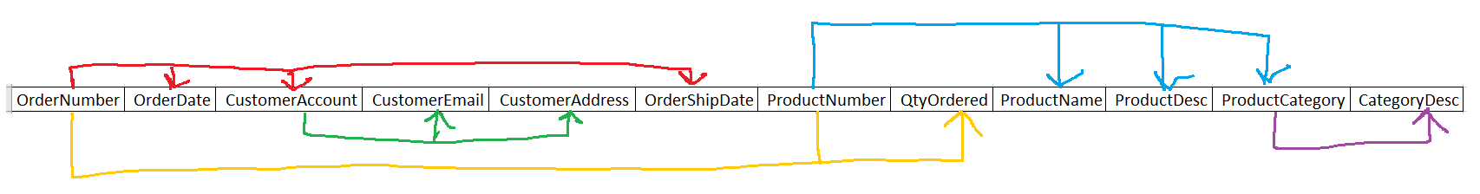

Decomposition of FDs that violate 2NF and 3NF:
- Order(OrderNumber, OrderDate, CustomerAccount(FK), OrderShipDate)
- Customer(CustomerAccount, CustomerEmail, CustomerAddress)
- Product(ProductNumber, ProductName, ProductDesc, ProductCategory(FK))
- Category(ProductCategory, CategoryDesc)
- OrderDetails(OrderNumber(FK), ProductNumber(FK), QtyOrdered)

